

The Rules of Kubb

The Aim of the Game
The aim of the game of Kubb is for one team to knock over the King after having knocked over all the Kubbs on the opposing side of the pitch.

Should a team knock over the King before knocking over all the opposing Kubbs, they lose!

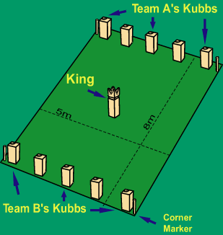
Setting up the Game
The game consists of the following pieces:

1 King
10 Kubbs
6 Throwing Sticks
4 Corner Markers

Place the pieces on the pitch as indicated right. The typical pitch dimensions are 8m x 5m (but you can reduce this to 6m x 4m for an easier game). The pitch should be relatively flat but Kubb can be played on grass, sand, gravel or even snow.

How Many People Can Play and Who Starts?
The players are divided into two teams with between 1 and 6 players on each side. You don't have to have the same number of players on each team, but it helps.

To choose which team starts, one player from each team stands behind the same base line and they each throw a Throwing Stick underarm towards the King. The starting team (Team A) is the team whose stick lands closest to the King without actually touching it.

Basic Game Play
Team A starts by standing behind their own base line and throwing the six Throwing Sticks at the Kubbs lined up on Team B’s base line. The aim is to try to knock over as many of these as possible. The Kubbs lined up on a team's base line are known as Base Kubbs.

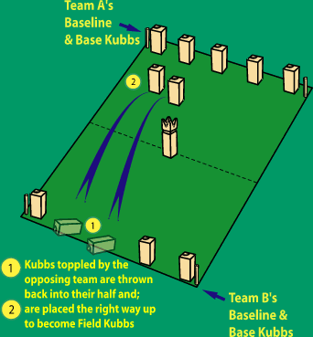
The Throwing Sticks must be held at either end (not in the middle) and thrown underarm and end over end. “Helicopter Throws”, where the Throwing Stick is spun horizontally, are NOT allowed.

Once Team A has thrown all its Throwing Sticks, Team B takes its turn. Standing behind its base line, Team B throws the Kubbs, knocked over by Team A (if there are any), into Team A’s half of the pitch, i.e. the area between the King and Team A’s base line and between the Corner Markers (see right). Team B has two attempts to throw each toppled Kubb into the opposing half of the pitch. Should any Kubb land outside this area more than once, Team A may place any such Kubb(s) anywhere on their own half of the pitch, but not closer than the length of one Throwing Stick from the King or a Corner Marker. Once all the toppled Kubbs have been successfully thrown onto the opposing side of the pitch, Team A stands these up, wherever they have come to rest. These are now known as Field Kubbs.

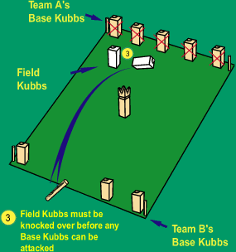
Team B then takes its turn to throw the Throwing Sticks. They must, however, knock over any Field Kubbs on Team A’s side of the pitch before attacking the Base Kubbs on Team A’s base line (see right). Should any Base Kubbs be knocked over before the last Field Kubb has fallen, these Base Kubbs should be placed upright again without penalty. Should Team A not have knocked over any Kubbs with its first throws, Team B may attack Team A’s Base Kubbs straight away.

Once Team B has thrown all its Throwing Sticks, Team A takes its turn, as described above, to throw back any toppled Field/Base Kubbs onto Team B’s side of the pitch and then tries to knock them over with the Throwing Sticks.

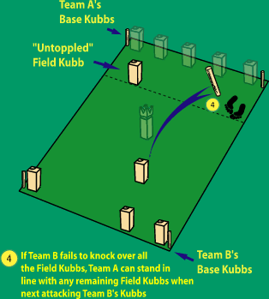
Note: Should Team B have failed to knock over all of the Field Kubbs on Team A’s side of the pitch, Team A may stand in line with the Field Kubb closest to the King when throwing the Throwing Sticks. This does not apply when throwing the Kubbs as these must always be thrown underarm from behind the team's baseline.

The game continues in this way with the two teams taking turns until one team knocks over all the Field and Base Kubbs on the opposing side of the pitch. They may then attack the King with any remaining Throwing Sticks.

Note: When attacking the King, the thrower must always stand behind the base line.

If the team then succeeds in knocking over the King, that team wins the set. Remember - should a team knock over the King before knocking over all the opposing Kubbs, they lose!

Miscellaneous and Optional Rules

NOTE: Kubb pieces are made of solid wood so may hurt or injure a person if struck by one. Please ensure that when not throwing, all players stand well back (at least 2-3 metres) behind the base line.

A match is played over the best of three sets.

To ensure that both teams get a turn, the King may only be attacked once both teams have had 1 round of throwing the throwing sticks; in the unlikely event that in the first round Team A knocks over all of Team B's Base Kubbs with the first 5 Throwing Sticks, Team A must pass with the final Throwing Stick and not attack the King.

A Throwing Stick may knock over more than one Kubb.

Kubbs should always be thrown underarm and from behind the base line. As opposed to Throwing Sticks, Kubbs may be spun in any direction.

When throwing, both feet should be between the Corner Markers

A Kubb which has been knocked over and then subsequently rights itself is classed as having fallen. It is also classed as fallen if the Kubb ends up lying against another Kubb or against a Throwing Stick.
As Kubb involves throwing blocks of wood at each other, it is in the nature of the game that the pieces may become dented/incur minor damage. This is to be expected and will not lessen the playing experience. It is recommended that the Kubb set is stored in the dry as extended exposure to moisture may damage the set.
Even though not part of the official World Championship Rules, it is common practice to play the "Tower" rule. This rule states that should the Kubbs strike each other when they have been thrown onto the opposing side of the pitch, they should be stacked on top of each other, in the form of a tower. There is no limit to the number of Kubbs that can be stacked in a tower (although putting more than three on top of each other can be quite a challenge). This only applies to Field Kubbs and not to Base Kubbs.

